Class: CMSC203 30377  
Program: Assignment 0

Instructor: Dr. Monshi

Summary of Description: Setup GitHub, Install and setup JDK, install and setup Eclipse and JavaFX

Due Date: 1/31/2023

Integrity Pledge: I pledge that I have completed the programming assignment independently. I have not copied the code from a student or any source.

Part 1: Setup GitHub:

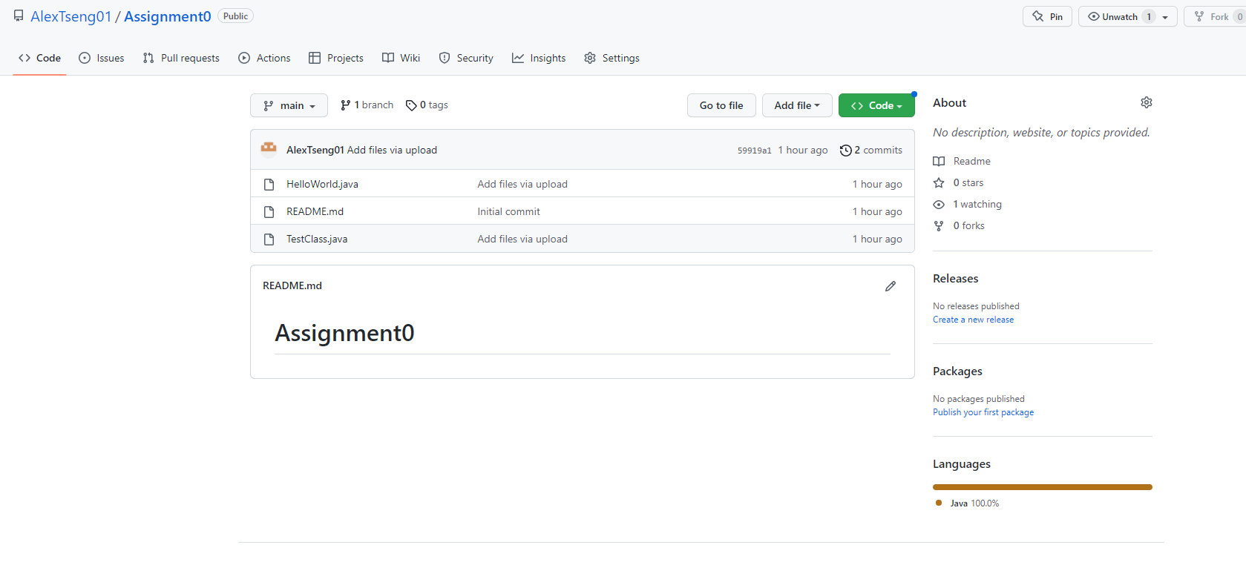

Part 2: Install JDK, Test java Application from Command Line:

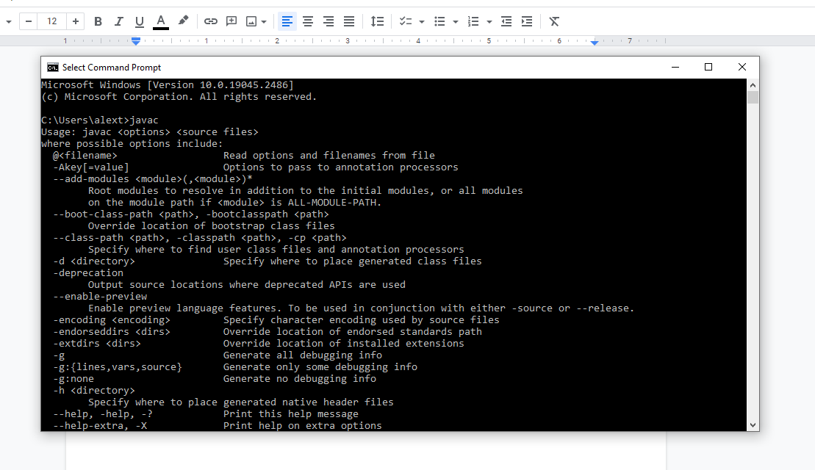

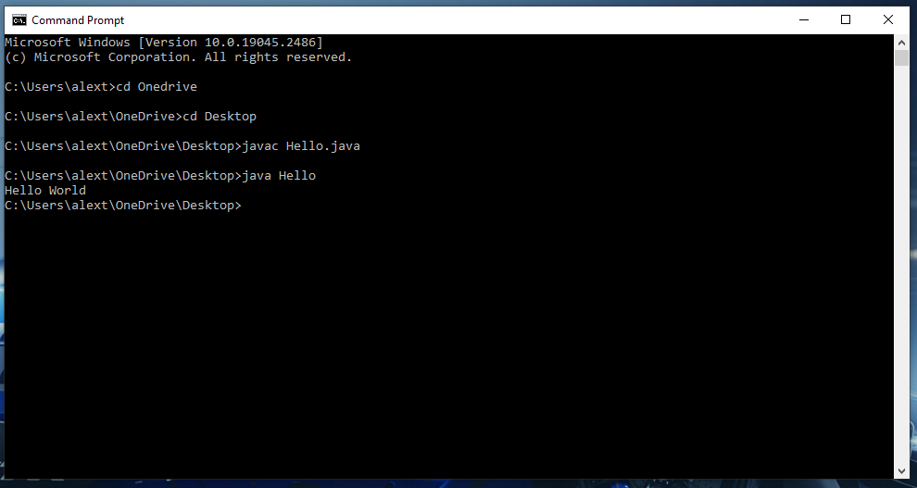

Part 3: Eclipse Installations:

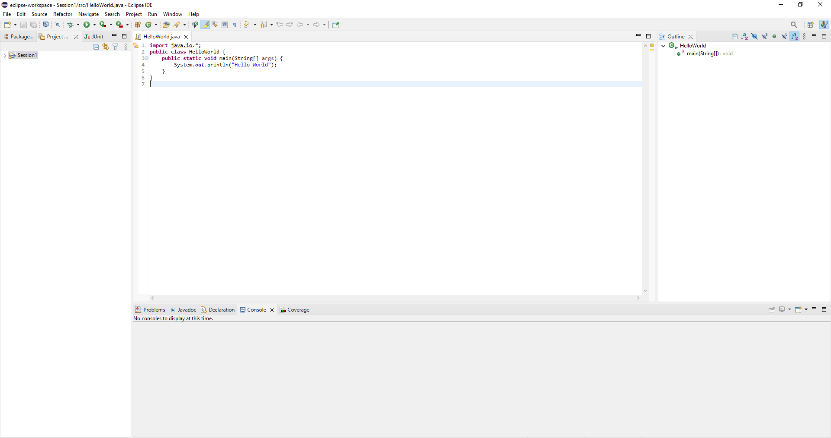

Part 4: Test Junit Program

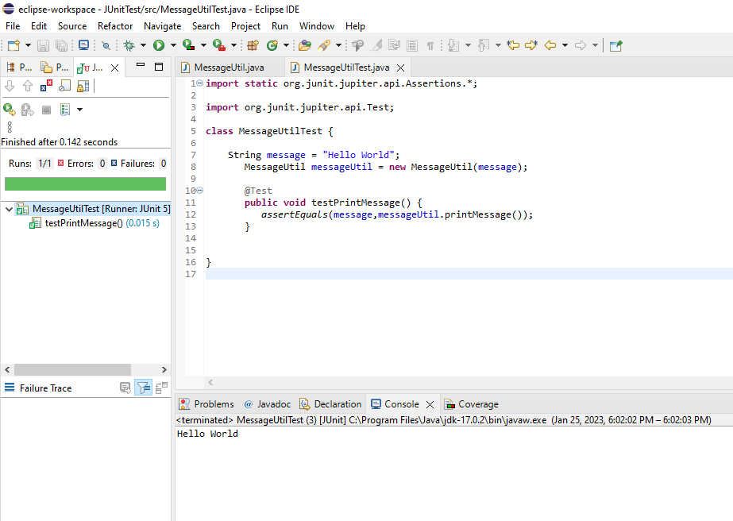

Part 5: Test JavaFX

